The Teign Room is a purpose-built, modern community venue. The room seats up to 100 people, although it can equally accommodate a small group for a recital or meeting.
The room has a sprung floor and is used as a dance, yoga and performance space. We can supply chairs and tables, flip-chart, DVD player, TV, digital projector, drop-down media screen and a fully-equipped kitchenette. A sound-proofed screen can be put in place to make the room private when visitors are in the Museum galleries.
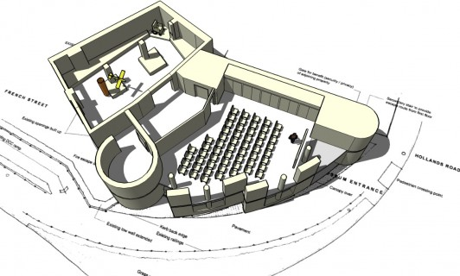
Sample seating layout for an audience of 50 with sound-proof screen in position
Teign Room hire charges (2011)
Regular hirers | £10 per hour
One-off hire by community organisations / charities | £12 per hour
Businesses | £50 for 3 hours (or part thereof)  £75 full day hire
Full use of AV | £15 per session  Use of 1 or 2 items, no charge
Use of kitchenette | Free
Hire for special events & La Terrasse roof terrace | Please enquire

